* First Screen : Ask for the Name and Number of Rooms and then Next Button.

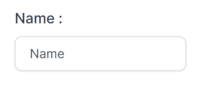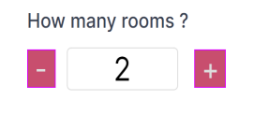

* Next screen, show total blocks based on total rooms added in First screen.
* Each block have 2 default guests in room.
* Give Add Guest option to add extra guest in each block.
* Date should be selected from **20/04/2024** to **28/04/2024.** (Disable other dates)
* No other validation required in any of the field except Date.

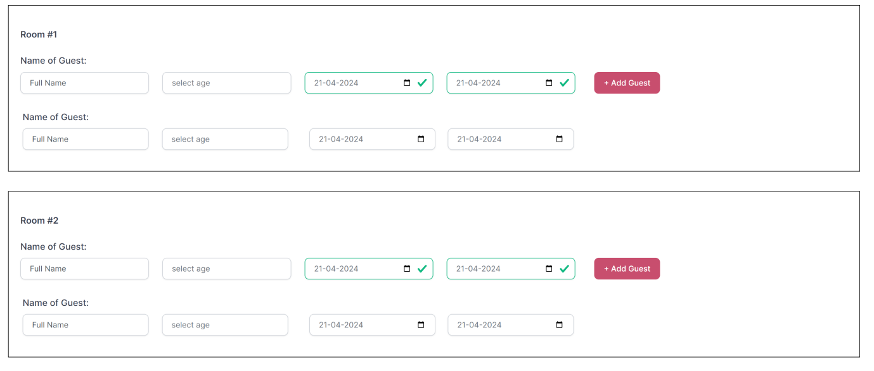

* Submit the form and save data to database.
* Show success or error message.

**Report :**

* Show one Report for date wise total guests based on submitted data.
* In Report, Name column must be from the First screen.

